2022 SOUTHEASTERN CALL MAKER COMPETITION

Best of Show 123 Jeff White

CLASS I Best of Class 123 Jeff White

Category 1 Short Box 1 123 Jeff White
2 187 Tony Quarino
3 122 Jeff White
4 186 Tony Quarino

Category 2 Long Box 1 125 Anthony Gizzo
2 183 Tony Quarino
3 185 Tony Quarino
4 114 Seth Halleyburton

Category 3 One Sided Box 1 124 Jeff White
2 189 Tony Quarino
3 188 Tony Quarino
4 N/A

CLASS II Best of Class 119 Thomas Waldron

Category 4 Slate 1 182 Brandon Washington
2 121 Thomas Waldron
3 175 Mitchell Johnston
4 120 Thomas Waldron

Category 5 Glass 1 119 Thomas Waldron
2 156 Lynn Gentry
3 118 Thomas Waldron
4 153 Lynn Gentry

Category 6 Other 1 205 Kevin Cantrell
2 178 Mitchell Johnston
3 164 (A) John Hood
4 166 Austin Long

2022 SOUTHEASTERN CALL MAKER COMPETITION

CLASS III Best of Class 191 Brian Lawter

Category 7 Turned Trumpet 1 191 Brian Lawter
2 100 Brian Mero
3 152 Rick Alessandrini
4 136 Daryal Gosey

CLASS IV Best of Class 108 Kevin Rouse

Category 8 Wing Bone 1 108 Kevin Rouse
2 109 Kevin Rouse
3 190 Brian Lawter
4 130 Steve Lawter

CLASS V Best of Class 181 Brandon Washington

Category 9 Scratch Box 1 181 Brandon Washington
2 150 Michael Terefenko
3 182 Brandon Washington
4 151 Michael Terefenko

Category 10 Push Pin 1 194 Marshall Wood
2 195 Marshall Wood
3 N/A
4 N/A

Category 11 Trough 1 197 Marshall Wood
2 196 Marshall Wood
3 132 Steve Sandidge
4 131 Steve Sandidge

2022 SOUTHEASTERN CALL MAKER COMPETITION

CLASS VI Best of Class 135 Daryal Gosey

Category 14 Crow 1 135 Daryal Gosey
2 179 Brandon Washington
3 170 Mitchell Johnston
4 164 (B) Bradley Humphrey

Category 15 Owl 1 111 Greg Longuillo
2 168 Mitchell Johnston
3 167 Mitchell Johnston
4 N/A

Category 16 All other calls 1 161 John Hood
(Predator, Grunt, 2 193 Brian Lawter
etc.) 3 Rodd Madison
4 162 John Hood

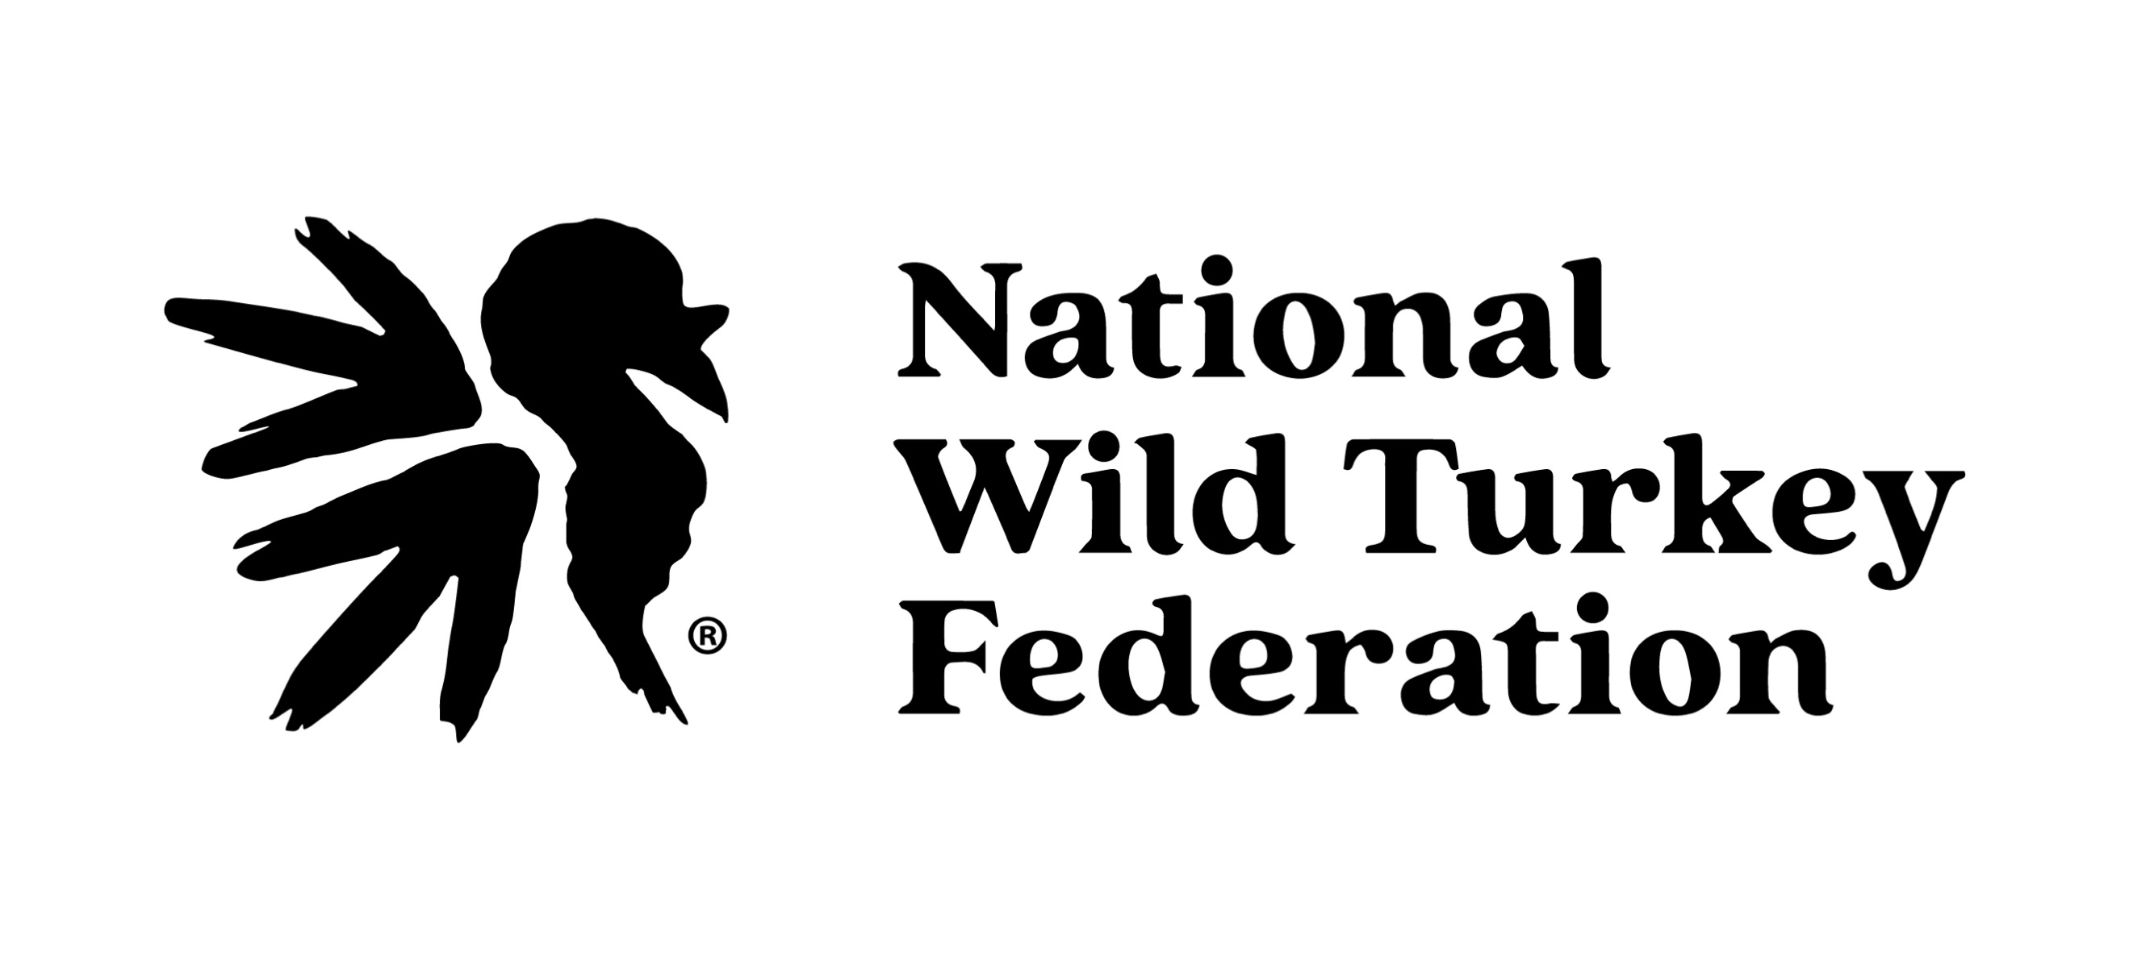
NCNWTF

